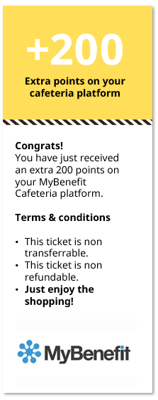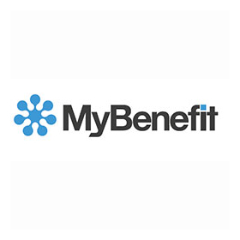

As Ingvar said *„(…) No one can be happy or do a good job unless they like the place where they work. After all, it’s there that they spend most of their waking hours.* ***Feeling appreciated and motivated leads to good results.”***

We'd like to thank you for the first months of your IKEA Journey. Especially we appreciate your willingness to learn, proactive attitude & engagement in People Operation Transformation project. In last month you provided a great support for new colleges by sharing your knowledge with them. We value your team player attitude. It's a real pleasure to work with you! Keep up the good job!

**YOU’RE THE BEST!**

This is the big thank you to:

**John Smith**

**Katarzyna Koźlicka**

PA/PY Deputy Team Leader

**Agata Bajsztok**

PA/PY Team Leader

**Agnieszka Choodowska**

PA/PY Team Leader

**María Belén Toro Mallero**

PA/PY Services Manager

**Congrats!**

You have just received an extra 200 points on your MyBenefit Cafeteria platform.

**Terms & conditions**

* This ticket is non transferrable.
* This ticket is non refundable.
* **Just enjoy the shopping!**

**+200**

**Extra points on your cafeteria platform**

SSC Poznan